|  |  |  |  |
| --- | --- | --- | --- |
|  |  | WEBSITE PROJECT REPORT  Beau Travis / WDD 130 / 12 Dec 2022 |  |
|  |  |  |  |
|  | | | |

|  |  |  |  |
| --- | --- | --- | --- |
|  |  |  | |
|  |  | Table Of Contents |  |
|  |  | Contents Table Of Contents 2Introduction 3Goals/Objectives 4Design Process 5Conclusion 6 |  |

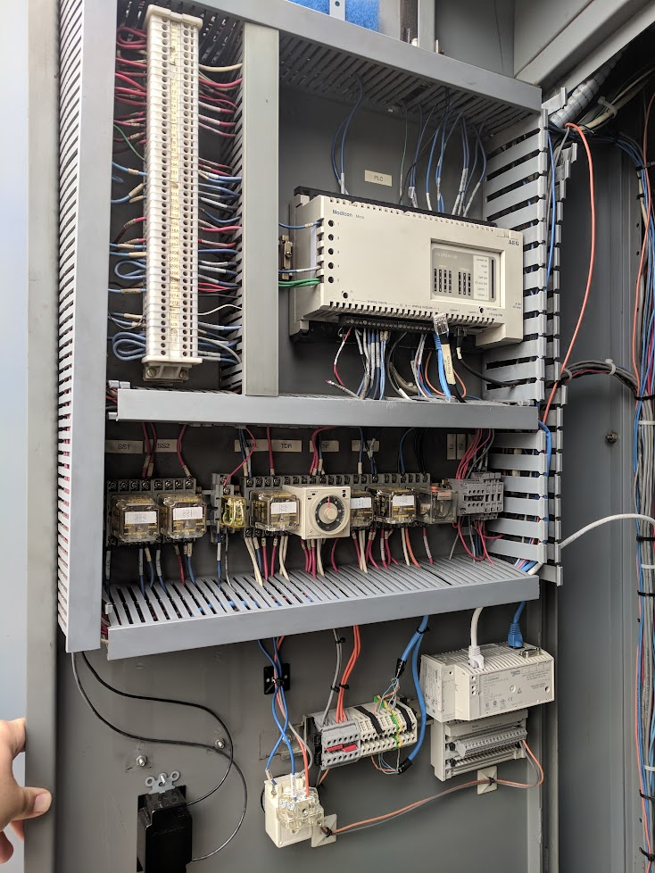

|  |  |  |
| --- | --- | --- |
| Introduction |  | |
| praetoriate.github.io/wdd130/scada/  Subject  The subject of my website is a high-level overview of what a SCADA system is. A SCADA system is the flavour of control system software that I design, implement, and maintain for water systems in California. It is a technology that is used *all over* the place and people don’t even realize that its there.  Audience  I get asked by people often about what I do for work and because it is such a niche thing, I struggle to give enough info for them to understand while keeping it simple enough to not watch their eyes glaze over. The people that will come to this website are intended to be primarily individuals outside of the industry with no knowledge of anything related to this, but also those who use the system and want to better understand what comprises it. | |  |

|  |  |  |
| --- | --- | --- |
| Goals/Objectives |  | |
| Reference  Aside from creating the website to satisfy the requirements for the course, I wanted to have something that I could actually use after this class was over. When I was working through the different topics that I could do, I realized I should do something that I was familiar with and that would be something people I knew would want to look at. There are all sorts of references that you can find when you google ‘What is SCADA?’ but most of them are either too high level, too vague, and/or created by a vendor that puts their own product or spin on it. I just wanted something fairly simple, direct, and unbiased towards any particular product.  Future Use  Since I have been in this industry for 12+ years now, I have still not developed any kind of personal reference that people can reference. I currently do not use LinkedIn, have a published portfolio, or anything else so having a platform/base that I can build off of will be really valuable. Its much more impressive to send a link to your own website rather than just a link to something on another platform. | |  |

|  |  |  |  |  |
| --- | --- | --- | --- | --- |
| Design Process | | |  | |
| A key component of an industrial control system is the Human/Machine Interface (HMI). The system provides data to, and receives input from, a user. This interface needs to be intuitive and easy to navigate. At first glance, a user should be able to see where different information can be found and know what can be interacted with. | | | |  |
| I decided to use similar design concepts from projects and documents that I have used in my work professionally. I felt that if it was something that worked for large and small water utilities in an engineering environment, it would be appropriate for the subject. The colour scheme is similar to user interfaces in controls and used a lot in Operation and Maintenance documentation. |  | A key component of an industrial control system is the Human/Machine Interface (HMI). This interface needs to be intuitive and easy to navigate. A website is a remarkably similar component that more people are familiar with. | |  |
| Whatever the interface, it should be easy to use and navigate. A website is a remarkably similar component that more people are familiar with, rather than (for example) an operator interface at a water treatment plant. | | | |  |

|  |  |  |
| --- | --- | --- |
| Conclusion |  | |
| In completing this project, I learned that there are programming and design concepts that are fundamental, regardless of the industry or application. It was fun to apply techniques and approaches that I use in a relatively unknown job on something more accessible to a wider audience. | |  |